Lauren Becker – HW 6 OOD (Fish Tank)

In addition to what was required of the assignment, I added the remainder of the fish images to the menu and added two MovementStyle subclasses called “NoMovement,” which was used so the shark could circle in one spot, and “VerticalMovement,” used for the Pufferfish.

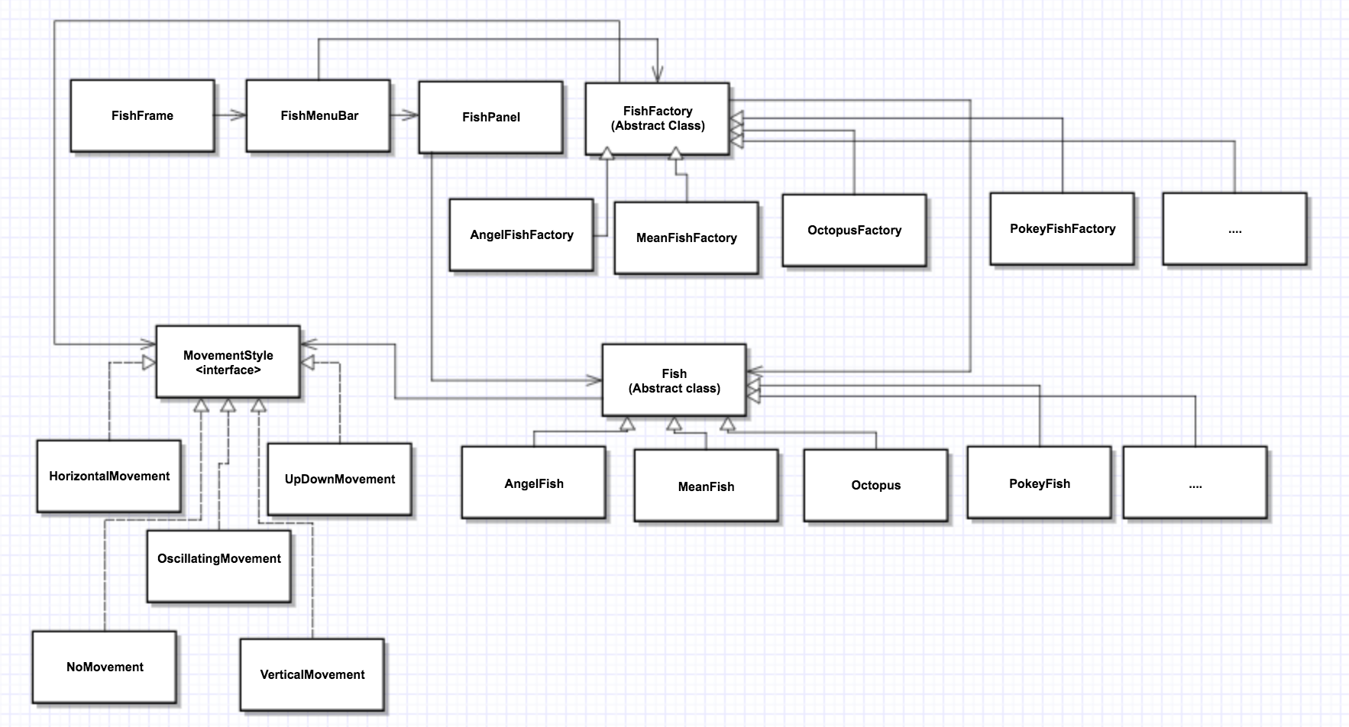

To add a new fish to the program:

* Create a FishFactory subclass that extends FishFactory. It should assign the new fish a movement and return a new Fish using the create() method
* Create a Fish subclass that extends Fish and specifies the images to use and gives the Fish superclass the movement style
* Add another ‘if’ statement to the static method getFactory in FishFactory.java to test for the fishtype of the new fish

**else** **if**(fishtype.equals("Fish Name"))

**return** **new** fishtypeFactory();

* In FishMenuBar.java add a new JMenuItem for the fishtype, and add an actionListener to this menu item so when it is clicked it created a new fish:

JMenuItem fishtype = **new** JMenuItem("Fish name");

newmenu.add(fishtype);

fishtype.addActionListener(e->newFish(fp,fishtype.getText()));